Minor Project Report

Title: Automobile Dataset Analysis using Pandas
Name: Muvvala Charmila
College: Aditya Institute of Technology and Management, Tekkali
Course: Data Science Internship Course
Year: 2025

Abstract
This project involves analyzing an automobile dataset using Python and the Pandas library. We clean the data, handle missing values, and perform statistical analysis to extract insights such as the cheapest and most expensive cars, average price by brand and body style.

Objective
To understand and analyze the structure and pricing patterns of an automobile dataset using basic data science techniques.

Technologies Used
- Python
- Pandas
- CSV File Handling
- Data Cleaning and Analysis

Dataset Description
The dataset contains various features of automobiles including company, body-style, wheelbase, engine-type, number of cylinders, horsepower, mileage, and price. The analysis is performed after cleaning missing values in the 'price' column.

Code Explanation
- Imported the pandas library.
- Read the dataset using `read_csv()` function.
- Displayed original and cleaned data.
- Filled missing values in the price column with the column mean.
- Found the cheapest and most expensive car.
- Grouped data by company and body-style to calculate average prices.

Output Summary
Data Analysis Completed Successfully!

Summary:
- Total cars after cleaning: 87
- Cheapest car price: 5151.0
- Most expensive car price: 45400.0
- Average car price overall: 15319.57
Graph: Average car price by Company
This graph shows the price variation across companies like Audi, Toyota, BMW, etc. It helps show which brands are cheaper
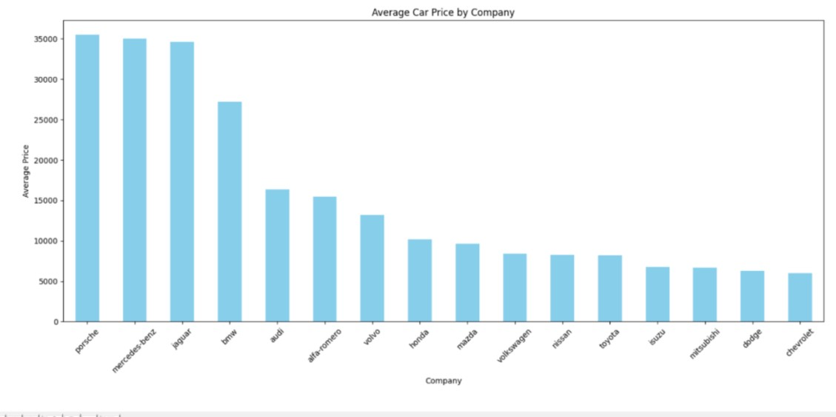

Conclusion
The automobile data analysis revealed the pricing trends based on car brand and body style. Luxury brands like Mercedes and Jaguar dominate the high-end segment, while Chevrolet and Dodge offer budget-friendly options. Such analysis helps in understanding the market positioning of different brands.

References
- https://pandas.pydata.org/
- https://www.kaggle.com/

